Robustness of twitter data of 2013 Glastonbury music festival
Given a social network, which of its nodes have a stronger impact in determining its structure is always a concept of deserving attention. More formally: which node-removal order has the greatest impact on the network structure is being experimented well before this implementation. We approach this well-known problem following the well research oriented papers in a setting that utilize social networks, using datasets of 2013 Glastonbury music festival. Our experiment highlight the robustness of networks in the structure of social networks and random network.
One of the most important notions that researchers have been trying to capture is “node centrality”: ideally, every node (often representing an individual) has some degree of influence or importance within the social domain under consideration, and one expects such importance to be reflected in the structure of the social network; centrality is a quantitative measure that aims at revealing the importance of a node. Among the types of centrality that have been in practice, many have to do with shortest paths between nodes; for example, the betweenness centrality of a node N is the sum, over all pairs of nodes u and v, of the fraction of shortest paths from u to v passing through N. The role played by shortest paths is justified by one of the most well known features of complex networks, the so-called small world phenomenon. A small-world network is a graph where the average distance between nodes is logarithmic in the size of the network, whereas the clustering coefficient is large than in a random Erdos Renyi graph with the same size and average distance. Here, and in the following, by “distance” we mean the length of the shortest path between two nodes. The fact that social networks (either electronically mediated or not) exhibit the small-world property is known at least since Milgram’s famous experiment and is arguably the most popular of all features of complex networks.
We thus consider a certain ordering of the nodes of a graph (that is supposed to represent their “importance” or “centrality”). We remove nodes (and of course their incident arcs) following this order, until a certain percentage of the nodes have been deleted . Finally, we compare the network parameters of Glastonbury data and average of three random networks with same number of nodes. The chosen ordering is considered to be a reliable measure of centrality ,which is sufficient to delete a small fraction of important nodes to change the structure of the network. In this work, we applied the described approach to a number of both networks, considering ordered removal of nodes, and obtained the following results: In all complex networks which is used here, the removal of a limited fraction of nodes does not change the key network parameters which will be explained below.

Average degree is simply the average number of edges per node in the graph. It is relatively straightforward to calculate. Average Weighted Degree is average sum of weights of the edges of nodes. The graph is designed in such a way that, weight of an edges represents, how many times that edges is traversed between a pair of nodes. If weight of node is higher, it means it has been visited many times than any other low weight degree node.
Network diameter is the shortest distance between the two most distant nodes in the network. In other words, once the shortest path length from every node to all other nodes is calculated, the diameter is the longest of all the calculated path lengths. Graph density is measured as the number of possible or potential connections (i.e., edges), over the number of actual connections . Density values range between zero and one, and can be thought of as the percent of all possible edges that are realized.

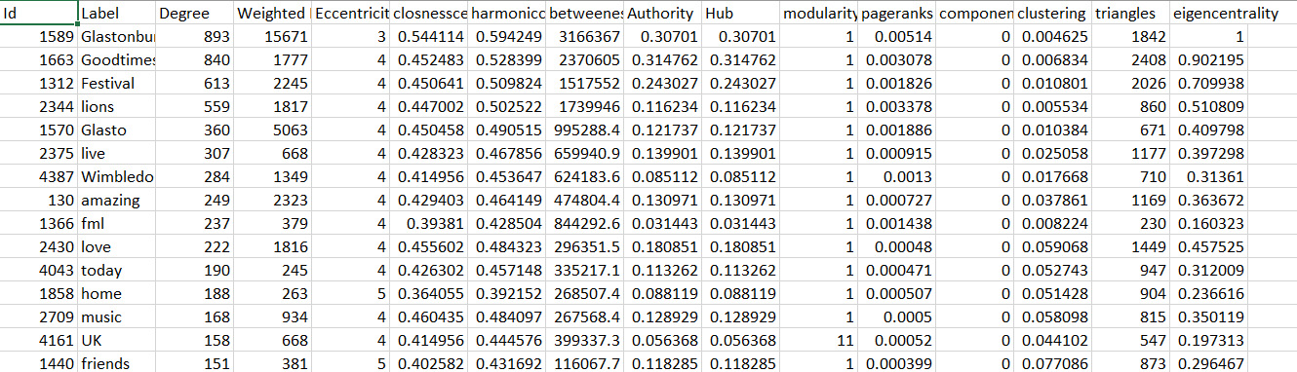

Modularity is one such concept that provides information about how the communities are formed within social network. Modularity is the fraction of the edges that fall within the given groups minus the expected such fraction if edges were distributed at random. A connected component is a subset of nodes such that there are two conditions this set of nodes satisfy. First, every node in the subset has to have a path to every other node in the subset. Average clustering coefficient is the clustering coefficient (Watts-Strogatz), when applied to a single node, is a measure of how complete the neighborhood of a node is. When applied to an entire network, it is the average clustering coefficient over all of the nodes in the network. Average path length is a concept in network topology that is defined as the average number of steps along the shortest paths for all possible pairs of network nodes. It is a measure of the efficiency of information or mass transport on a network.
The idea of grasping information about the structure of a network by repeatedly removing nodes out of it is not new: Albert, Jeong and Barabasi study experimentally the variation of the diameter on two different models of undirected random graphs when nodes are removed either randomly or in “connectedness order” and report different behaviours. More recently, node-centrality measures that look at how some graph invariant changes when some vertices or edges are deleted have been studied by identifying nodes that maximally disconnect the network.
We considered several different strategies for removing nodes from a graph. Some of them embody actually significant knowledge about the structure of the graph, whereas others are very simple (or even independent of the graph) and will be used as baseline. As we handle a undirected network ,we requires a symmetric graph . Initially we pick random nodes and remove them from the graph. It is important to test against this unusual practice as we can show that the behaviour we observe are due to the peculiar choice of nodes involved, and not to some generic property of the graph. We later resorted to large degrees first and we remove nodes in decreasing degree order. This strategy is an obvious baseline, as degree centrality is the first shot at centrality in a network. Social networks are much more resistant to node removal. There is no strict clustering, nor definite hubs, that can be used to eliminate or elongate shortest paths. This is not surprising, as networks emerging from social interaction are much less drafted as we can say there is less page mappings or definite hierarchy.
Experiment results:
Number of nodes: 4555
Number of edges: 15643

Network Parameters | Glastonbury
Network Parameters | 100% | 90% | 80% | 70%
Average_Degree | 6.867 | 6.791 | 6.621 | 6.53
Average_Weighted Degree | 7.217 | 7.14 | 6.993 | 6.84
Network diameter | 6 | 6 | 6 | 8
Radius | 1 | 1 | 1 | 1
Average_path_length | 3.145 | 3.128 | 3.103 | 3.196
Avg_clustering_coefficient | 0.873 | 0.889 | 0.887 | 0.898
Graph_density | 0.001 | 0.002 | 0.002 | 0.002
Modularity with resolution 1 | 0.659 | 0.658 | 0.654 | 0..652
No of communities | 72 | 50 | 53 | 64
Connected components | 55 | 36 | 27 | 24
Triangles | 25492 | 24874 | 24183 | 17370

Network Parameters | Avg_Random
Network Parameters | 100% | 90% | 80%
Average_Degree | 181.87 | 155.07 | 138.32
Average_Weighted Degree | 181.87 | 155.07 | 138.32
Network diameter | 3 | 3 | 3
Radius | 2 | 2 | 2
Average_path_length | 1.95 | 1.95 | 1.96
Avg_clustering_coefficient | 0.04 | 0.04 | 0.04
Graph_density | 0.04 | 0.04 | 0.04
Modularity with resolution 1 | 0.065 | 0.065 | 0.074
No of communities | 7 | 8 | 7
Connected components | 1 | 1 | 1
Triangles | 7008471 | 4391121 | 487266

We have removed the percentage of nodes in the order of 10,20 and 30 and observed the robust behaviour of Glastonbury dataset. The average degree and path length display least change and remain well connected.We have explored experimentally the results of node removal. We have confirmed some of the experimental results that appeared in the previous papers. In particular, we have shown the lucid structural difference between social networks and random networks, and that it is important to test node-removal strategies until a significant fraction of the edges have been removed. Probably the most important conclusion is that “scale-free” models, which are currently proposed for social networks need more analysis. For more intuitive analysis, the above conducted practice can only make sense as long as they are adopted as baselines. For instance, checking whether node removal alters the clustering coefficient would not be so interesting, because the clustering coefficient of each node depends only on the structure of the neighbourhood of each node. Thus, by removing first the nodes with high coefficient it would be trivial to make the clustering coefficient of the graph decrease quickly.

